Creating a new BAFA membership
Go to www.bafa.azolve.com and click on ‘New Member’

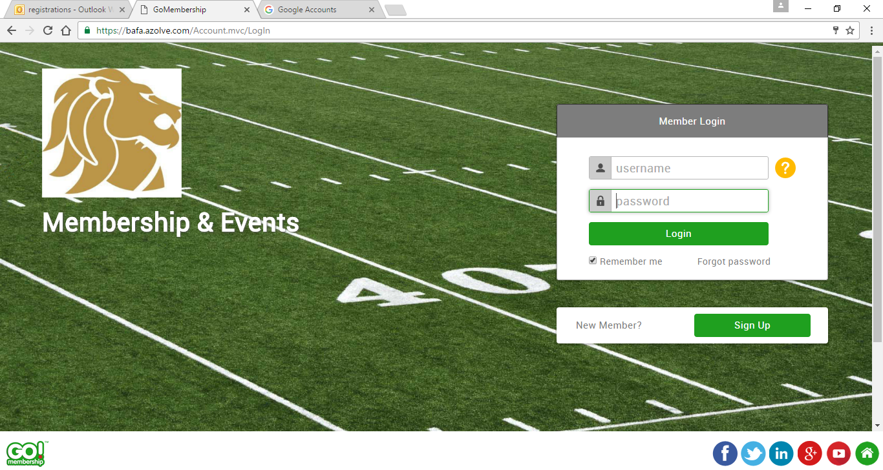

Please complete all sections. Section 3 will be your account details. The Username automatically self populates with your email address. You can change this to a new username of your choice if you prefer.

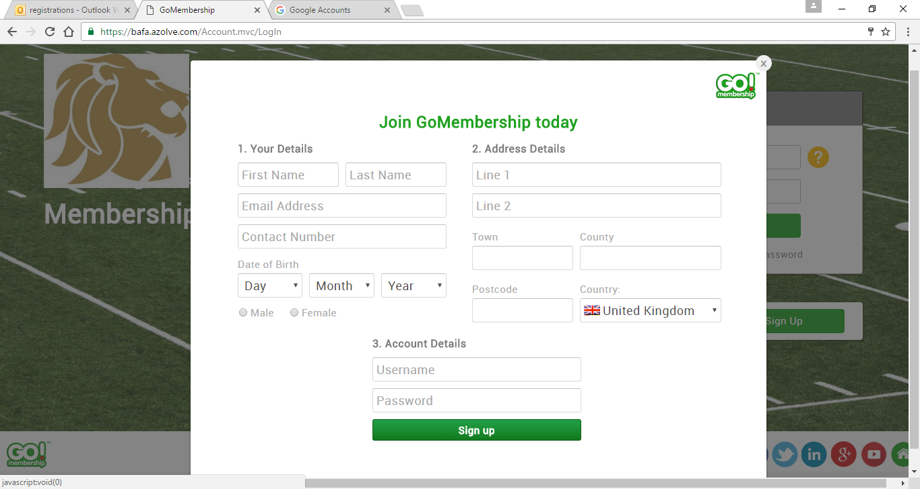

Your profile page will then be brought up. Please do not select a club at this point. The first step here is to add your profile picture. This needs to be a passport style photo, a clear image of your face. Please be aware, a group photo, or a photo with you wearing helmet etc will not be accepted and may result in you not appearing on your game day roster. As well as photo upload there are 3 sections within this page that need completing. Profile, Member Details and BAFA Membership.

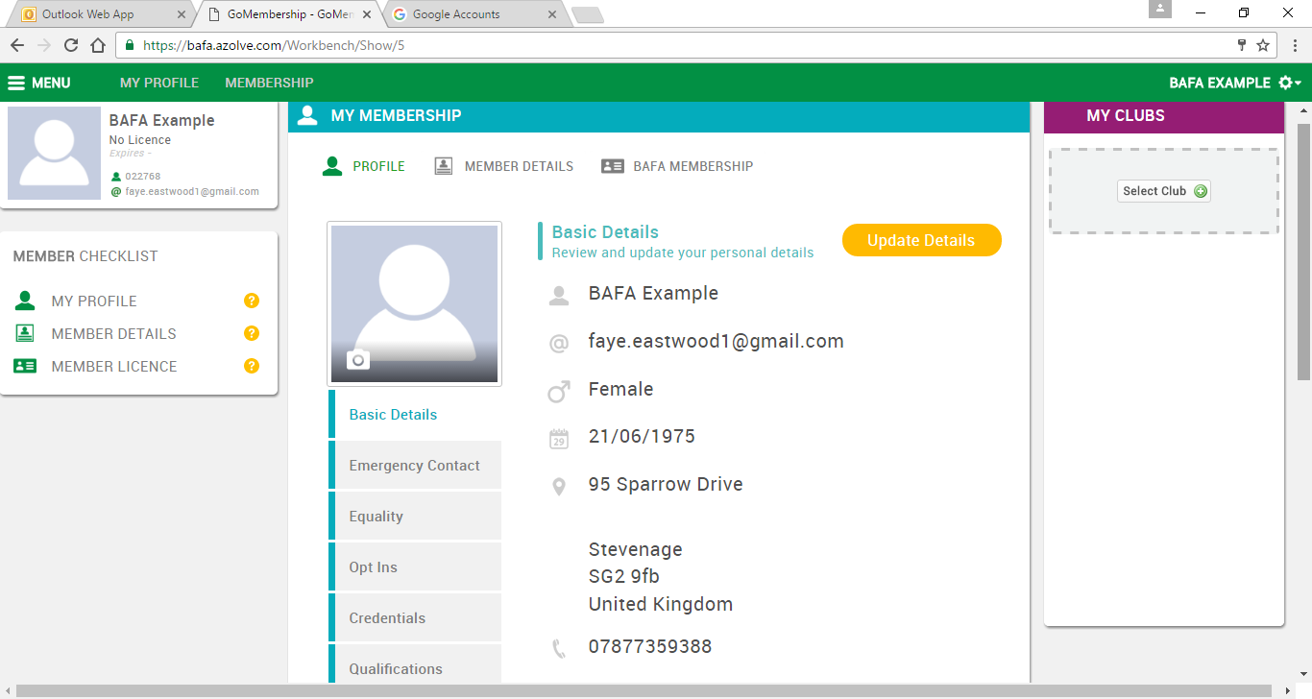
Each section then has subcategories which need to be completed. Please select Update Details and fill out the required details.
The BAFA Membership tab looks like this:
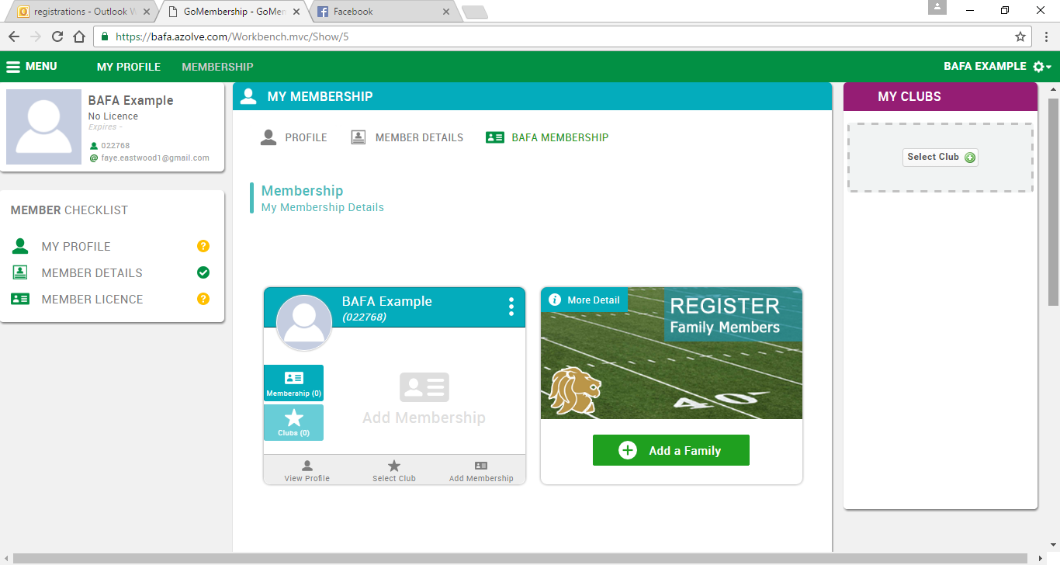
At this point you are able to select your club. Please make sure you click on the right club as this locks it in once you have selected. The next stage is Add Membership.
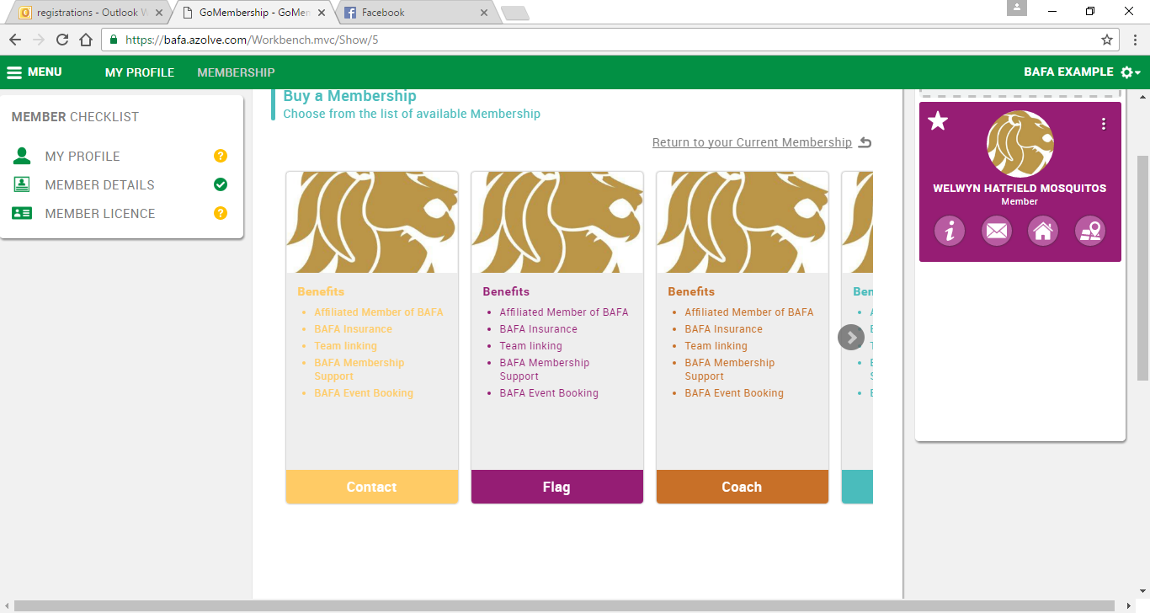
Four options are now available to you. Contact and Flag are for players. Then you have Coach and Other (you will need to scroll over Slightly for this option). If you are a player/coach there is a box within Contact for you to tick. Clicking on an option then gives you a couple of drop down boxes to choose from and also the Upload ID section.
The system requires 2 items to be uploaded, 1 of which needs to be photo ID. Documents accepted:
- Passport
- Driving Licence
- Identity Card
- Utility Bill
- Bank Statement
- Letter from HMRC

‘Other’ documents can include a letter from your local authority or employer. Please add any reference numbers included on the document. If no reference number is available please enter xxxx. If your document does not include valid from/expiry dates, please enter today’s date. The expiry date will automatically be populated with the date that we will require your ID to be updated.

If you are under 18 we will accept parental details as proof of address. Under 18s can also upload their Bus or Train pass, Student card, or Young Scot card. If no form of photo ID exists then a copy of birth certificate will be accepted. However, please note that should you get to any National Finals competitions then additional photo ID may be requested.

Once you have uploaded your details you will see notification at the bottom that ID is pending approval. This can be ignored for now as it is just reference for you that the documents have been uploaded on to your profile. Scroll down and select Finish. You will then be taken to the payment page. Please check to see if all details are correct and that the correct fee, as per below, has been applied.

- Player Coach Flag £37
- Adult Contact £35
- Adult flag £24.50
- Junior Contact £25
- Youth Contact £20
- Youth Flag £15.50
- Cadet Flag £15.50

Please follow the onscreen instructions to complete your payment. There will be an option to print your invoice confirmation once you have made your payment. You will also receive your confirmation via email.
If you have any questions please do not hesitate to contact registrations on registrations@britishamericanfootball.org

