Renew membership
bafa.azolve.com
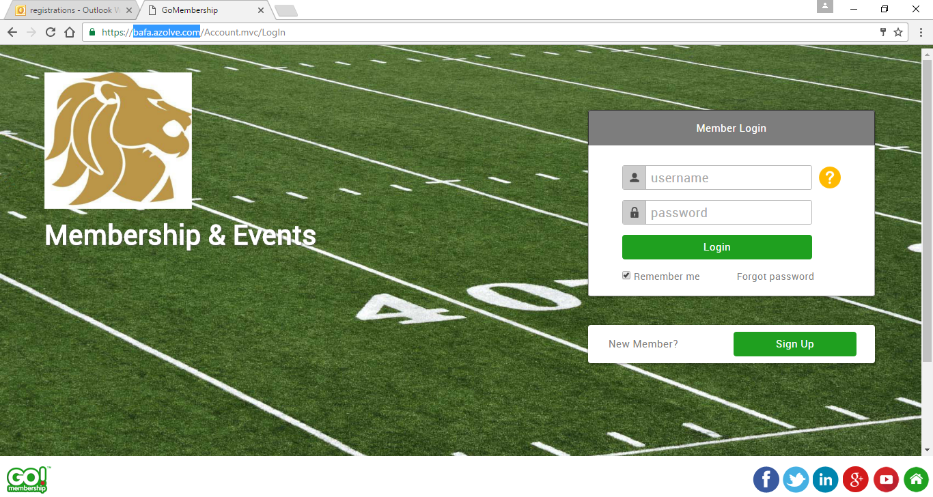

Your Username and Password will be the same as previous. If you cannot remember the password please select the ‘forgot password’ link. If you have forgotten your Username please contact registrations@britishamericanfootball.org.
When you have gained access please click on ‘My Profile’
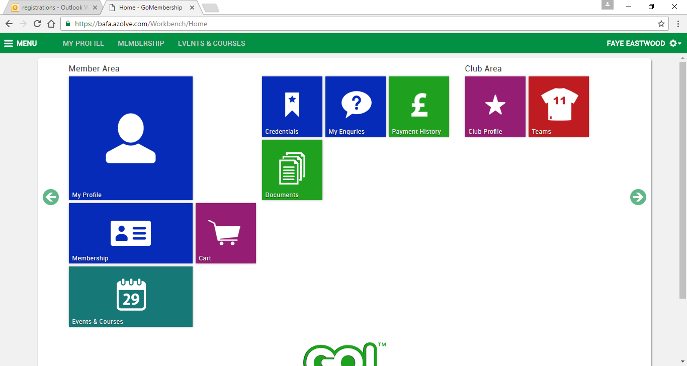

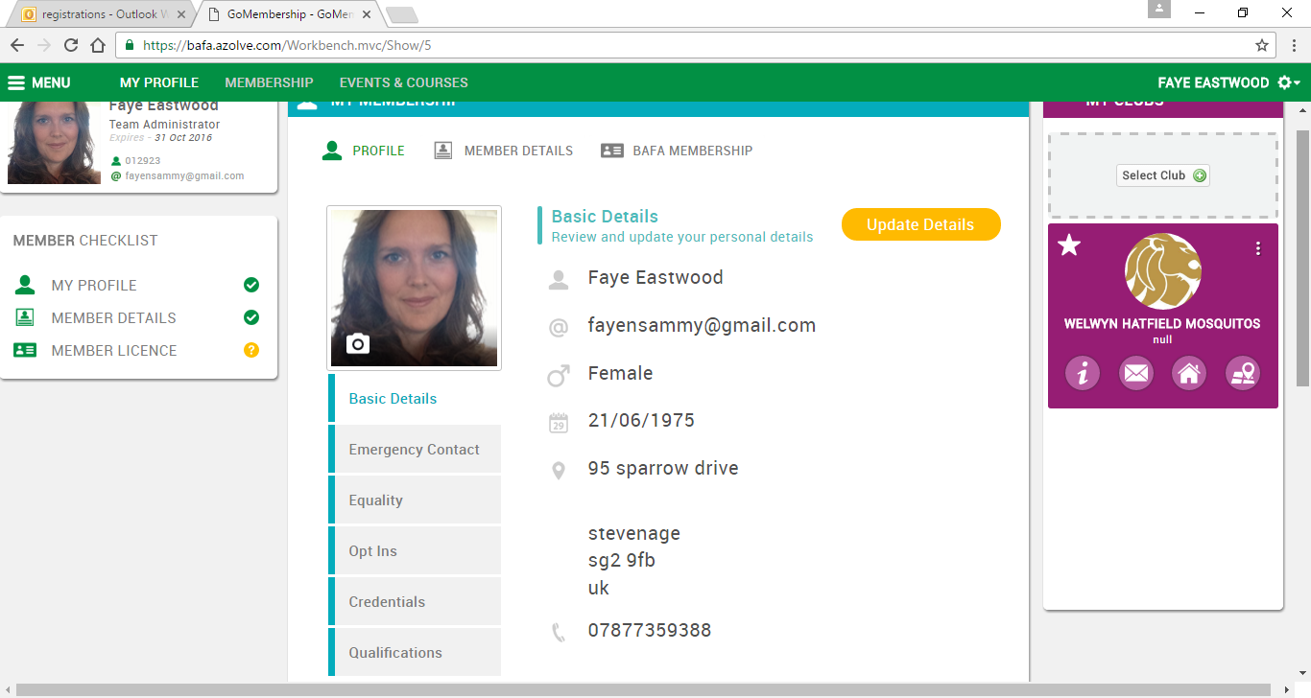
Here you will find 3 categories that need completing, Profile, Member Details and BAFA Membership. Please go into each section listed under your photo in the middle of the page and update all the details requested. You will need to click the yellow Update Details within each section. Kindly note, some sections are mandatory.
The BAFA Membership screen will be something like this:
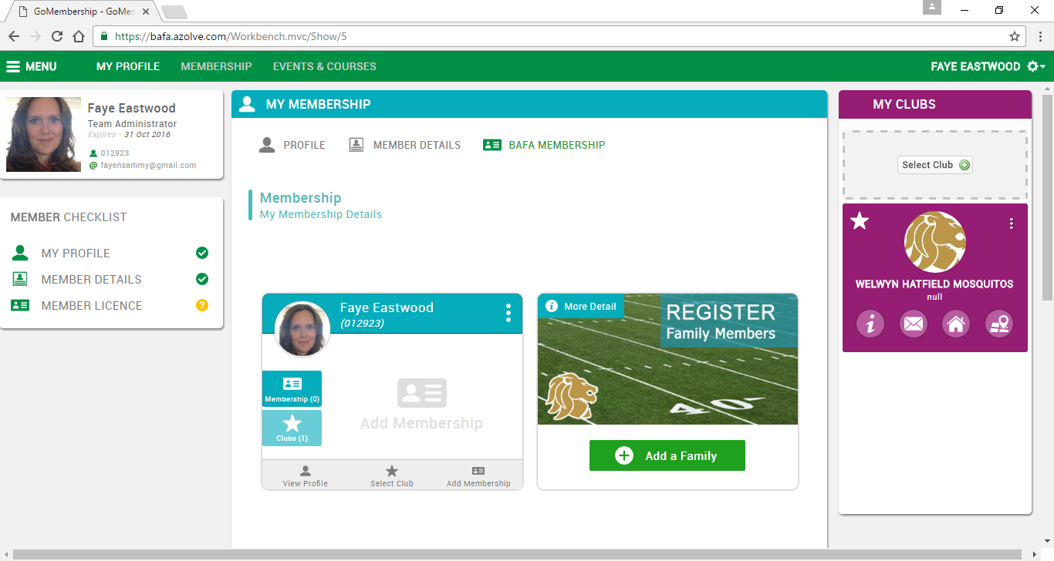
Please select Add Membership.
You will be given 4 options. Please select your primary role here (not discipline). Contact (if you are a player), Flag (again, if you are a player), Coach (or player coach) or Other (Team admin who doesn’t play or coach, physio, photographer etc). By selecting one of these options you will then be presented with the following:
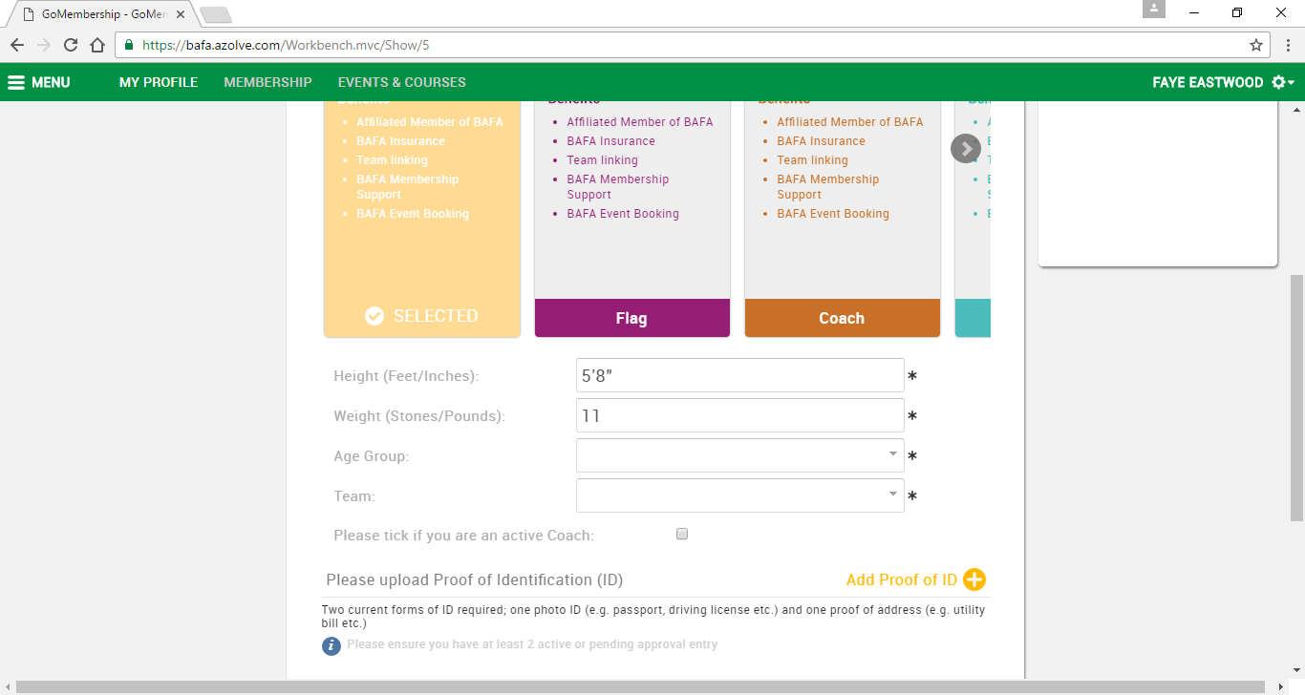

Please complete the details, your current team should appear here. Please update your profile with current proof of ID. The system requires 2 items to be uploaded, 1 of which needs to be photo ID. Documents accepted:
- Passport
- Driving Licence
- Identity Card
- Utility Bill
- Bank Statement
- Letter from HMRC

‘Other’ documents can include a letter from your local authority or employer. Please add any reference numbers included on the document. If no reference number is available please enter xxxx. If your document does not include valid from/expiry dates please enter todays date. The expiry date will automatically be populated with the date that we will require your ID to be updated.

If you are under 18 we will accept parental details as proof of address. Under 18s can also upload their Bus or Train pass, Student card or Young Scot card. If no form of photo ID exists then a copy of birth certificate will be accepted. However, please note that should you get to any National Finals competitions then additional photo ID may be requested.

A pending approval message will then appear on the screen if both items have been successfully uploaded. This can be ignored at this time. Scroll down and select finish.
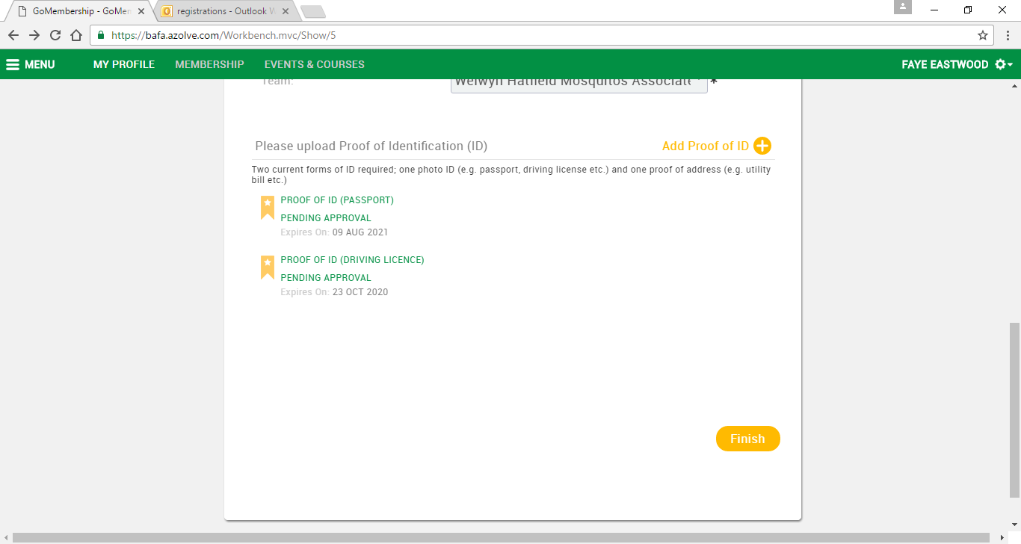

Please check that the details in the payment screen are correct then follow the onscreen instructions to complete your payment.
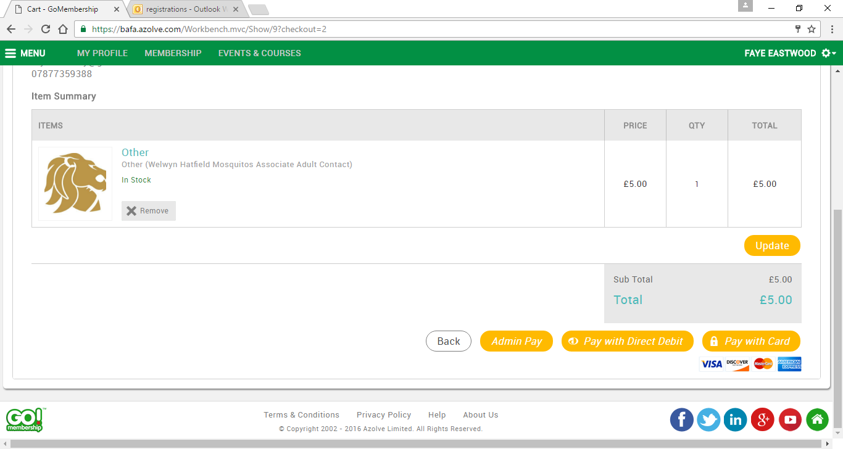
There will be an option to print your invoice confirmation once you have made your payment. You will also receive your confirmation via email.
If you have any questions please do not hesitate to contact registrations on registrations@britishamericanfootball.org

